Out put Assignment 9

1. Create AFTER UPDATE trigger to track product price changes

· Create product_price_audit table with below columns:

· Create a trigger function with the below logic:

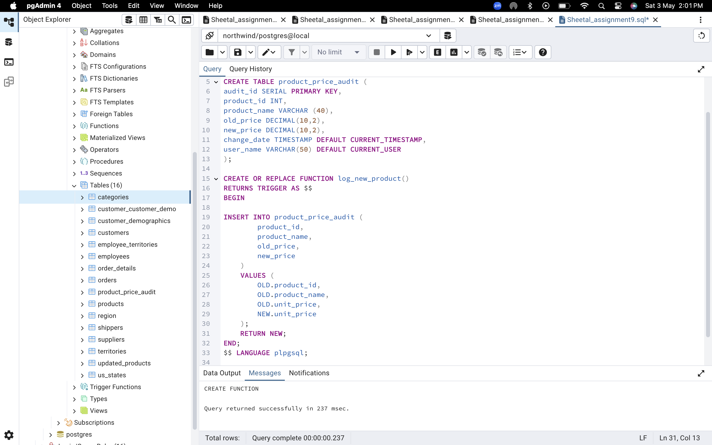

· Create a row level trigger for below event:

AFTER UPDATE OF unit_price ON products

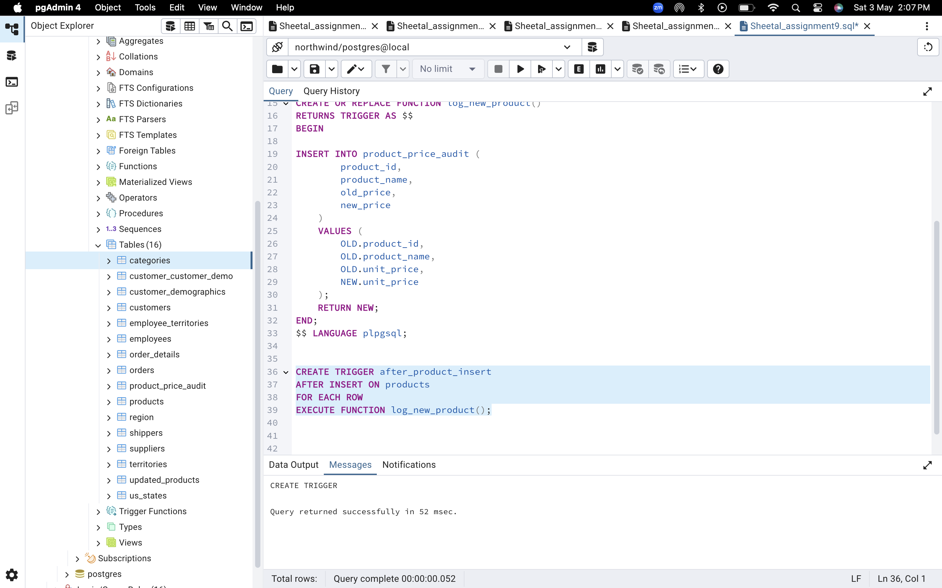

* Test the trigger by updating the product price by 10% to any one product_id.

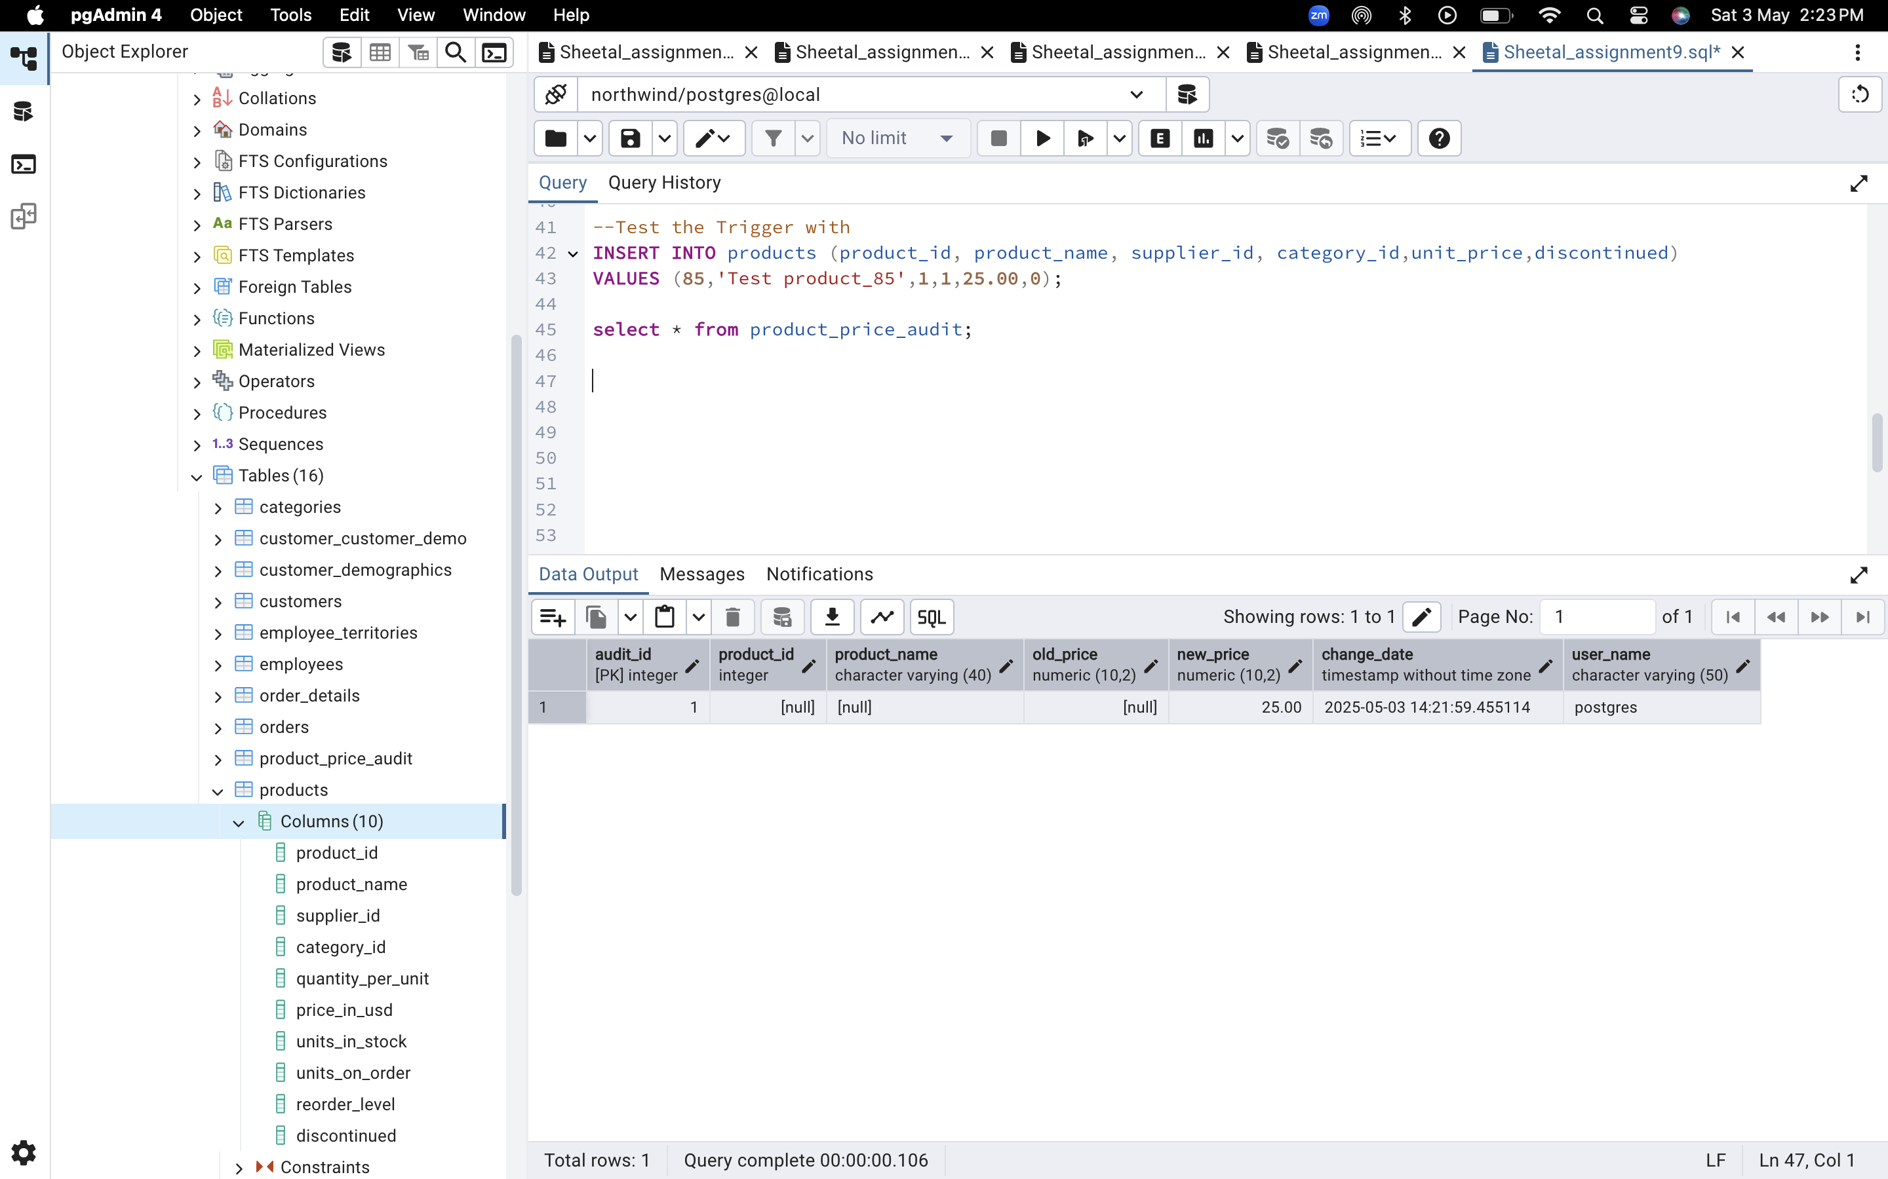

2. Create stored procedure using IN and INOUT parameters to assign tasks to employees

-- Create table employee_tasks:

-- Insert employee_id, task_name into employee_tasks

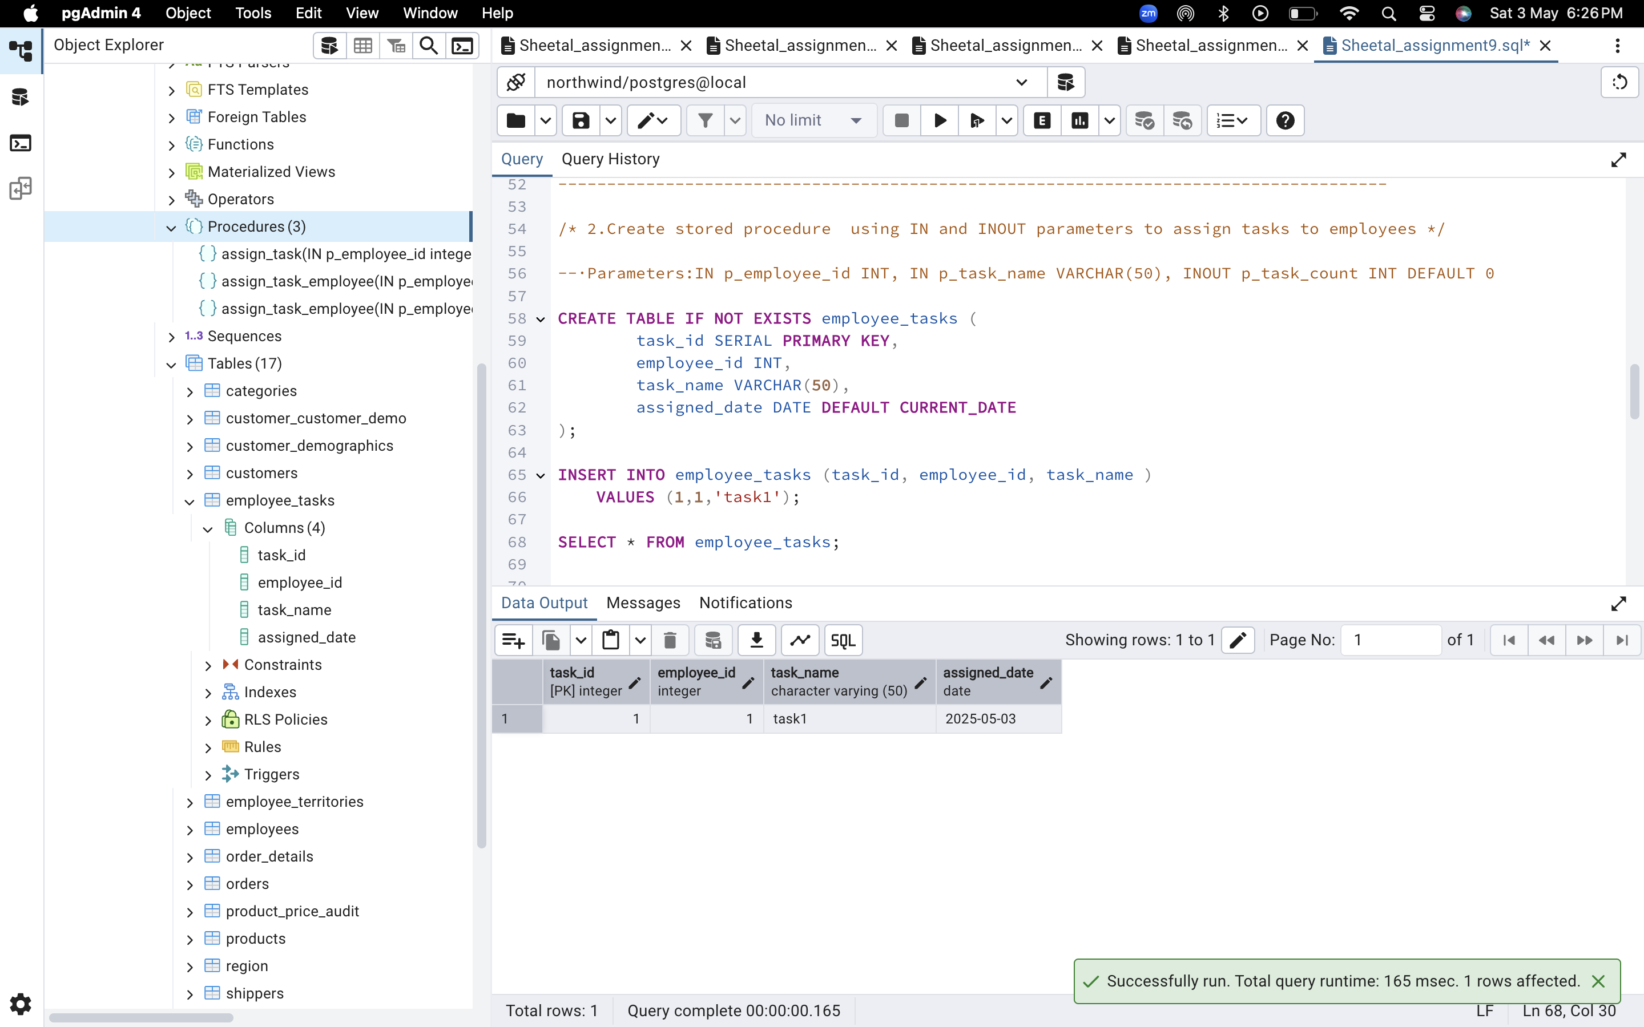

Count total tasks for employee and put the total count into p_task_count

